Seat Cushion, Rear
Sedan
Removal
- Apply knee pressure to lower front portion of the rear seat cushion. Push rearward to disengage rear seat cushion pad and frame (600A88) from rear seat cushion front retainers (63370).
- Remove rear seat cushion from vehicle.
Installation
- Position rear seat cushion assembly into vehicle.
- Place rear safety belt and buckles (60045) on top of rear seat cushion.
- Apply knee pressure to lower portion of rear seat cushion pad and frame. Push rearward and down to lock the rear seat cushion pad and frame into position.
- Pull rear seat cushion pad and frame forward to make sure it is secured into rear seat cushion front retainer.
Cushion, Rear Seat Sedan
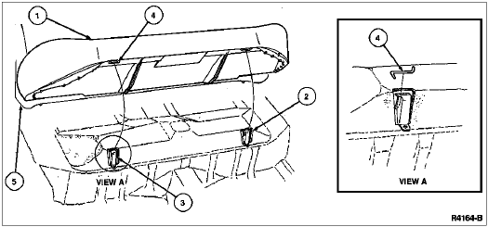

Seat Back, Rear
60/40 Split Bench—Sedan
Removal
- NOTE: Safety belt bolts do not secure seat back to vehicle.
Remove rear seat cushion as described.
- Fold down back seat and remove two bolts in the center of each seat back striker plates.
- Remove two bolts from outboard rear seat back frame retaining brackets.
- Lift seat back up and pull forward to remove from vehicle.
Installation
- Follow removal procedure in reverse order.
- Tighten bolts to 19-26 Nm (14-19 lb-ft).
Rear Seat Back—Sedan
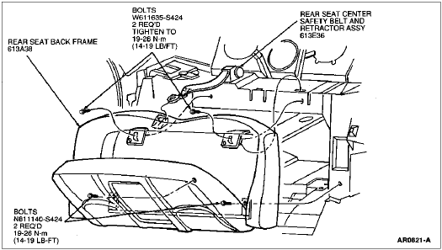

Trim Panel, Package Tray
Removal
- Remove rear seat as described in Section 01-10 .
- Remove upper quarter trim panels as described.
- Remove package tray trim panel (46668) by pulling package tray trim panel forward and upward.

Installation
- Follow removal procedure in reverse order.
